**How to test the project through Postman**

# Salient Features of this application based on .NET CORE

* Implemented Dependency Injection
* Implemented Token Based Authentication
* Implemented API Error Handling
* Implemented Repository Pattern

1. Authenticate the user with the below URL  
     
   URL: <http://localhost:56000/api/authenticate?username=Normal&password=normal>  
   Or  
   URL: <http://localhost:56000/api/authenticate?username=Privileged&password=privileged>  
     
   On Successful authentication you will get the token as below   
     
   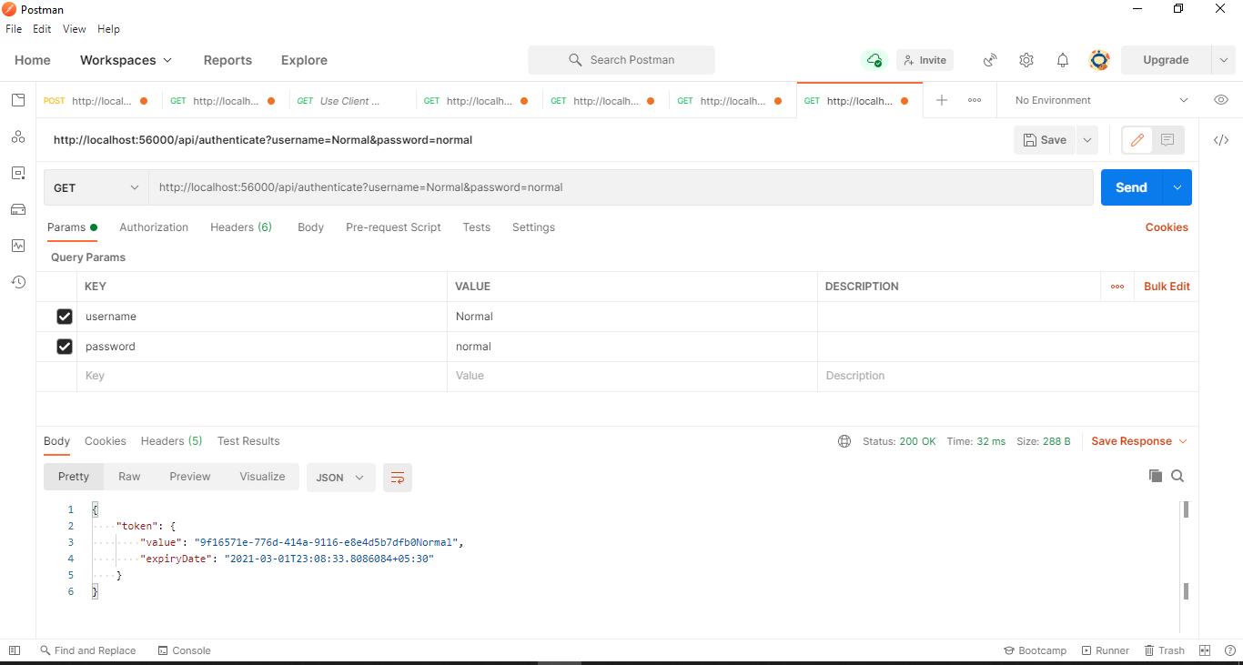

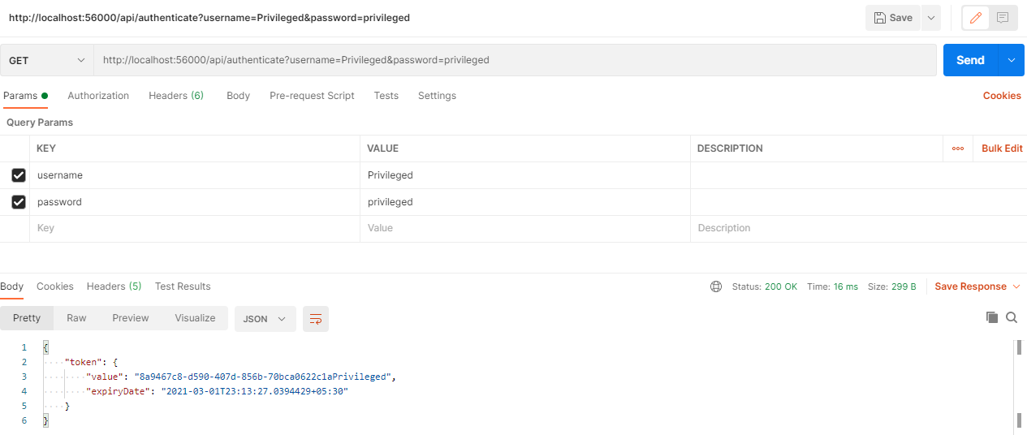

On Unauthorized access you will get the below error  
  
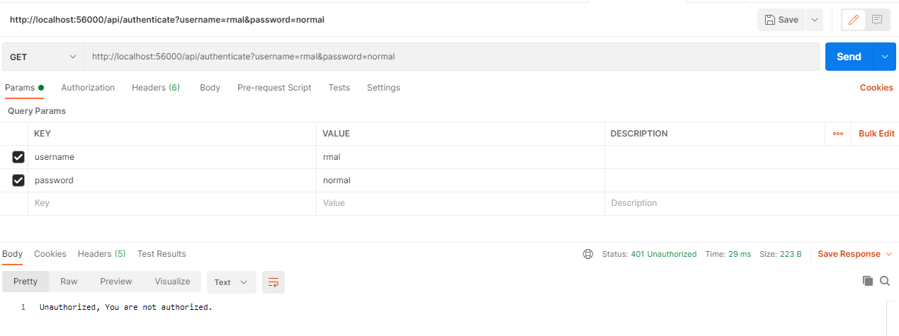

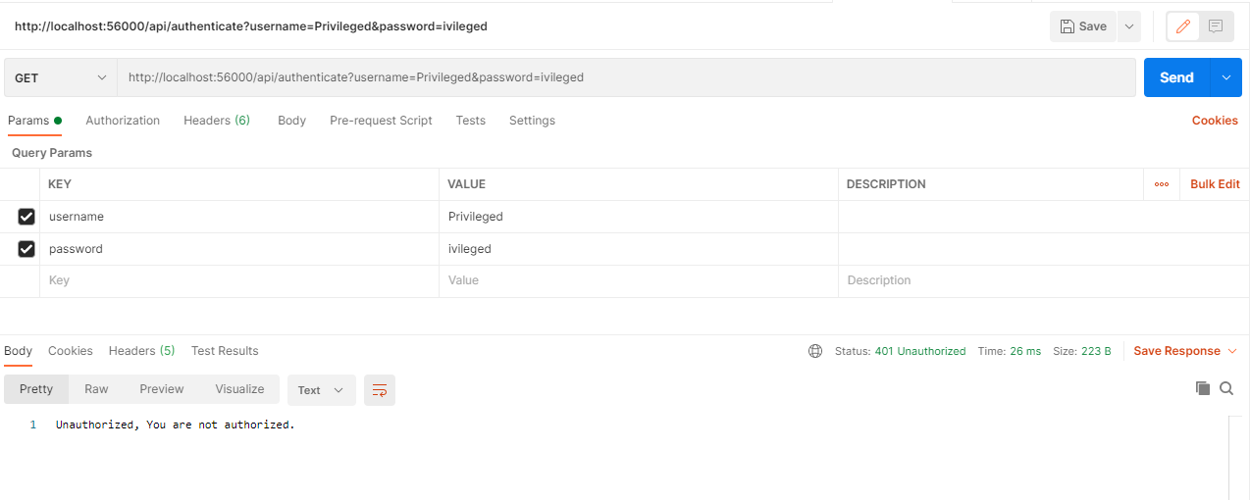

1. To See the Logged In User, enter the below URL  
     
   Remember to pass the Authorization Token while calling the below API’s  
     
   URL: <http://localhost:56000/api/user/Normal>  
   URL: <http://localhost:56000/api/user/Privileged>  
     
   Token Header: Authorization  
     
   If the user is present you will see the below message  
     
   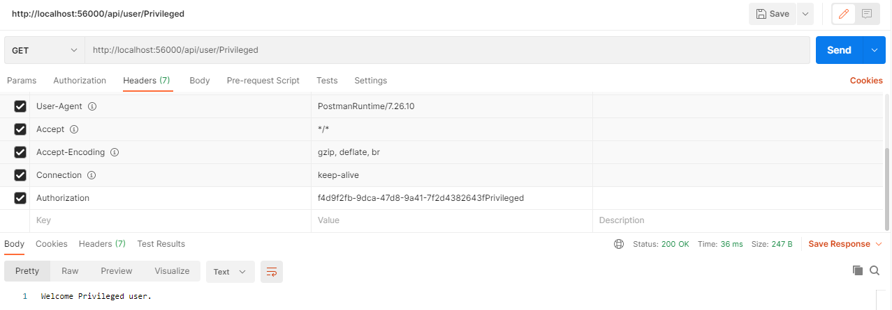  
     
     
   If the user is not present  
     
   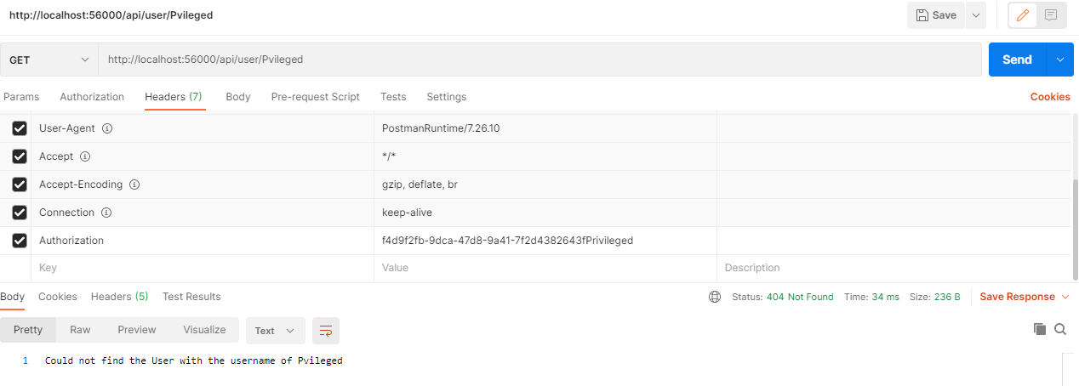

## Calculate the Total Amount by using the below API’s

Remember to pass the Authorization Token while calling the below API’s  
  
URL: <http://localhost:56000/api/user/calculateprice?goldPrice=10&weight=15&discount=2>

Token Header: Authorization

If you are a Privileged user, the total amount will be shown with the discount as below screen  
  
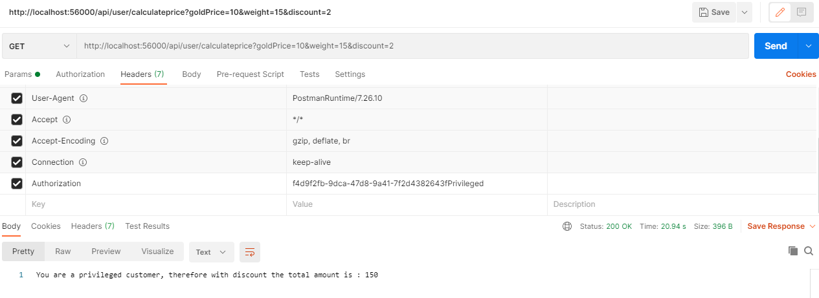  
  
  
If you are a Privileged user, but you have not entered any discount  
  
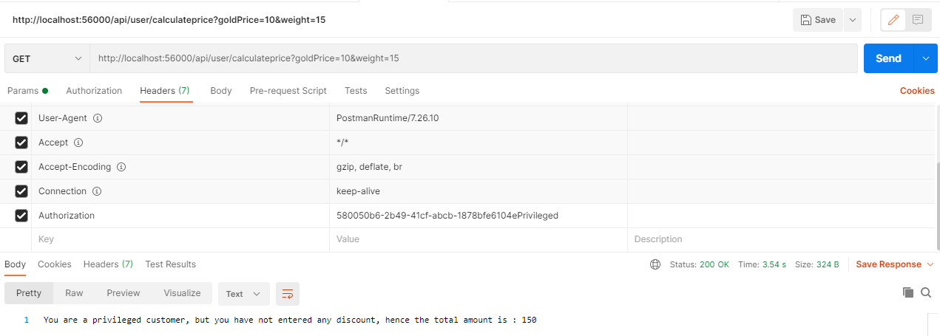  
  
  
If you have not entered either gold price or weight  
  
  
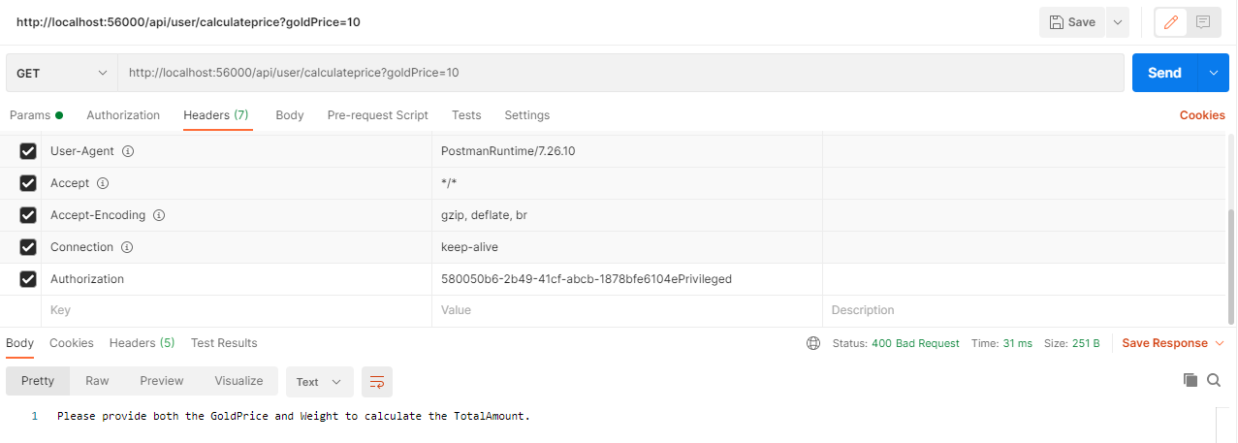

## Print functionality

Remember to pass the Authorization Token while calling the below API’s  
  
URL: <http://localhost:56000/api/user/printscreen>

Token Header: Authorization

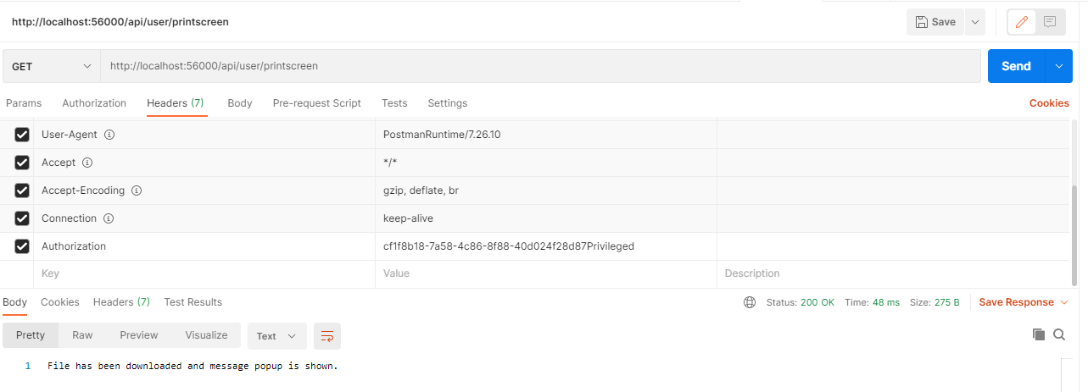

In downloading a file you can get below 2 outputs

URL: <http://localhost:56000/api/user/printscreen>

Token Header: Authorization

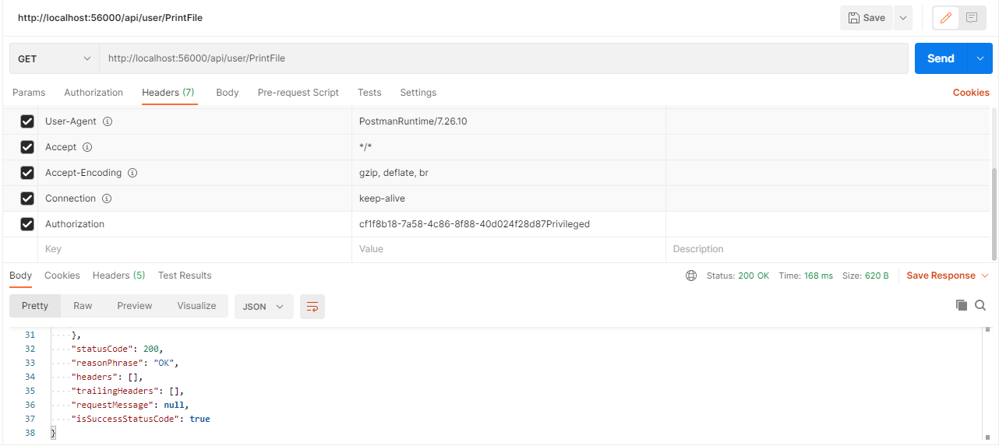

The above shows the JSON output

**If you want to see the file content in the output**then comment the below line  
//return result;  
  
And uncomment the below line

return File(fileMemStream, "application/pdf", "test.pdf");

